INOVA WEB APPLICATION TESTING PROCESS RECRUITMENT MODULE

- Recruitment>Job Vacancy:

I have checked the Job Vacancy is working fine; but problem is excel export report not working, Please check.

- Recruitment>Profile submission:

I have checked the Profile submission is working fine;

- Recruitment > Feedback Template Mapping:
I have added the department based on Feedback Template Mapping. Again, new Feedback Template Mapping add show the error message. Please check.
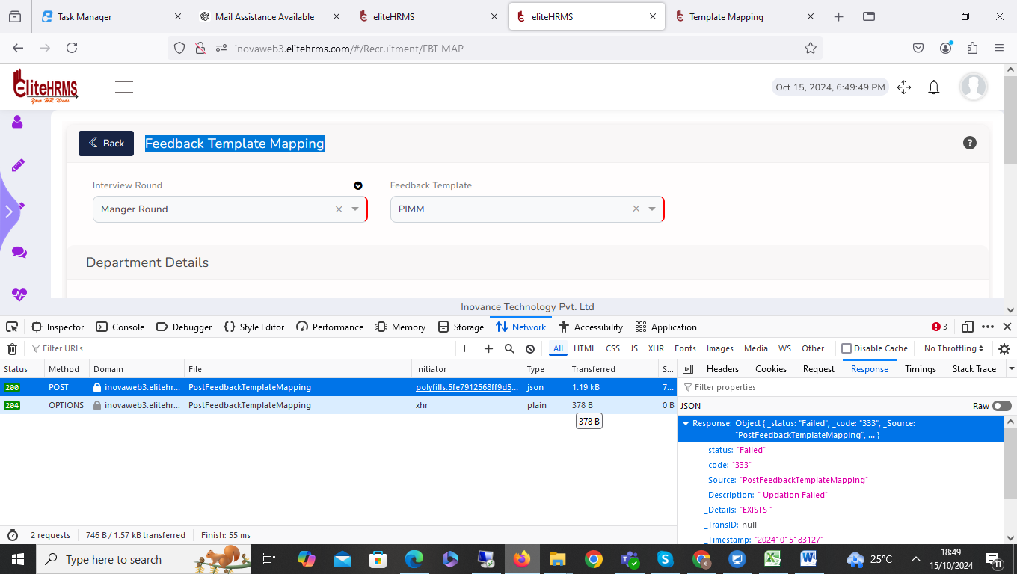

- Recruitment > Interviewer List

Interviewer List created page employee details is not visible. Please check.
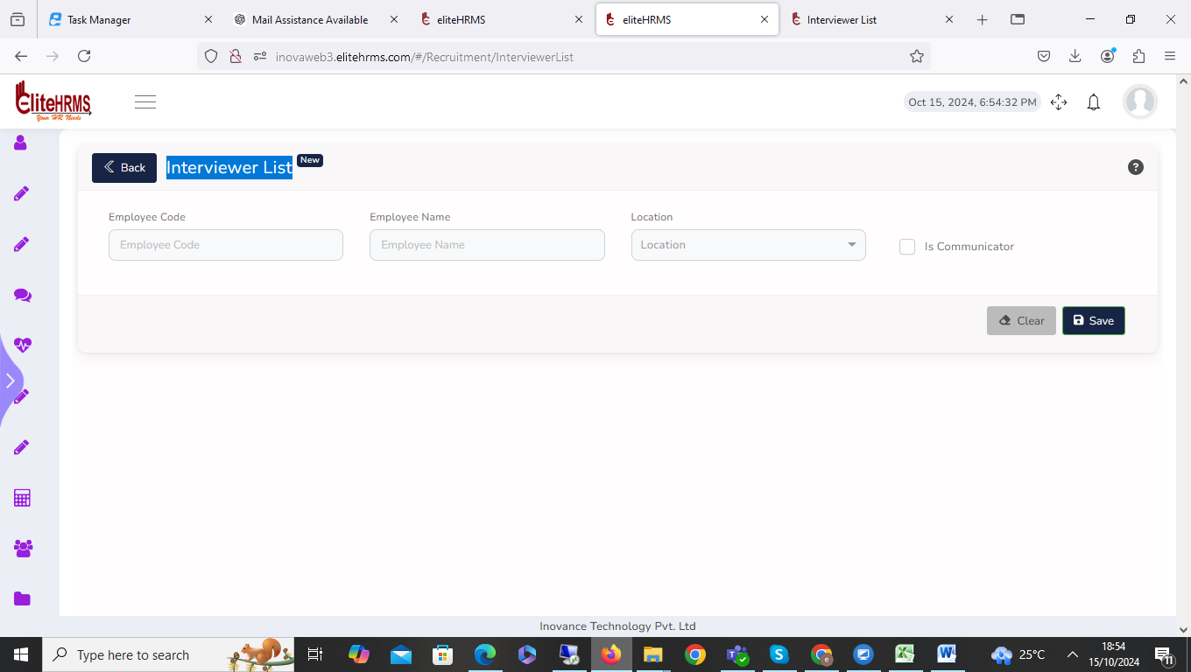

- Recruitment > Profile Scanning & Interview Scheduling:

Profile Scanning & Interview Scheduling screen is working fine.

- Recruitment > Profile Tagging:
Profile Tagging screen scan resume options clicked duplicate record has been shown, please check the issue.
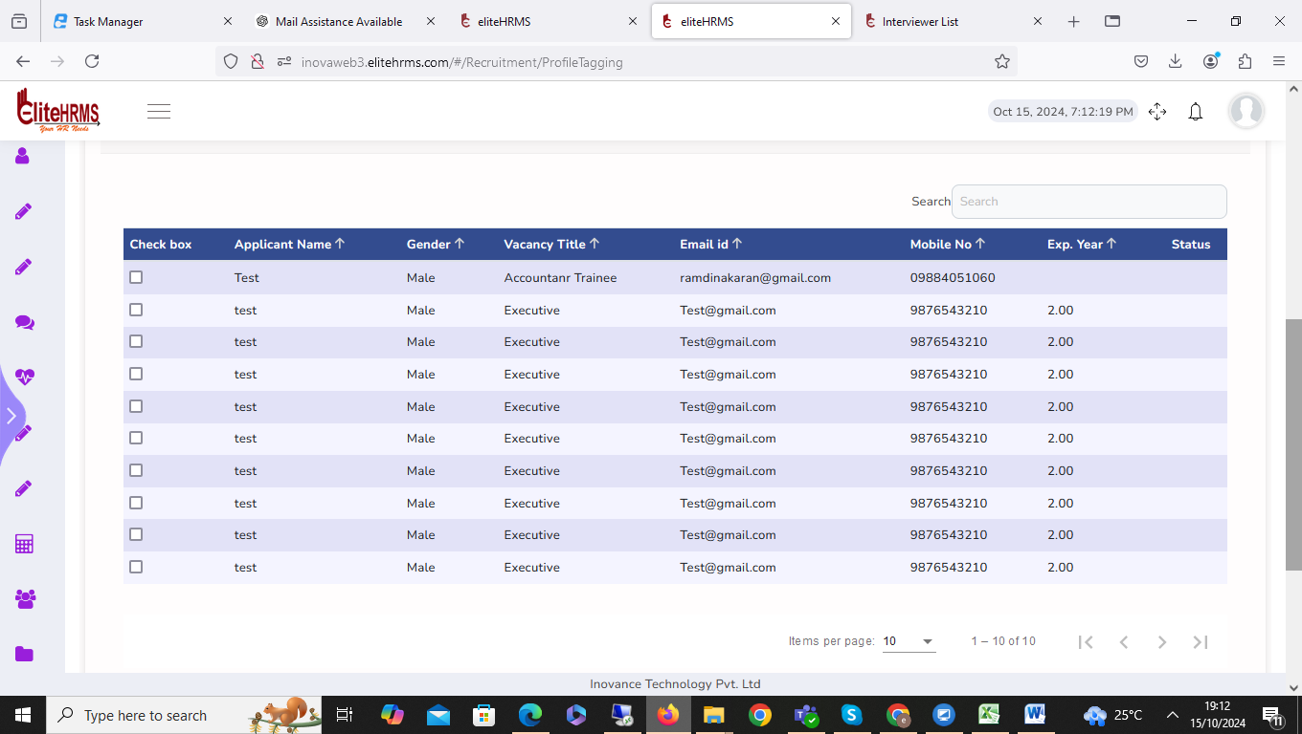

- Recruitment >Shortlisting & Resource Planning :

Shortlisting & Resource Planning screen scan resume options clicked duplicate record has been shown, please check the issue.

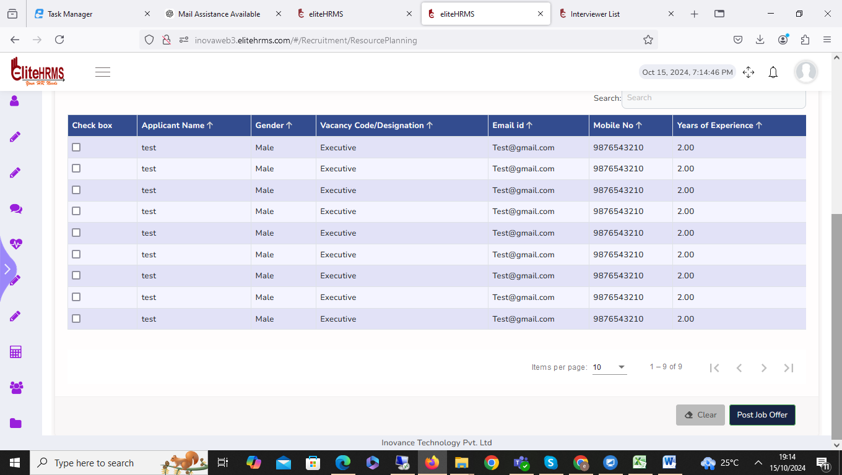

- Recruitment >Interview Bulk Rescheduling:

Interview Bulk Rescheduling screen is working fine.

- Recruitment >SMS & Email Resending:

I have encountered an issue with the SMS & Email Resending screen. The vacancy details dropdown is showing incorrect information, and the correct details are not being displayed. Additionally, the Send SMS and Send Mail buttons are not functioning properly.

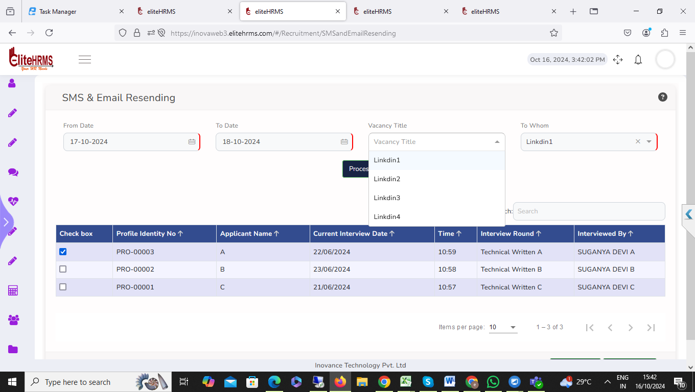

- Recruitment > Job Vacancy Upload:

The Job Vacancy Upload screen. When attempting to download the upload template file, the file downloads in text format instead of the expected format, and the file name appears as "attachment." The file is also unable to open correctly

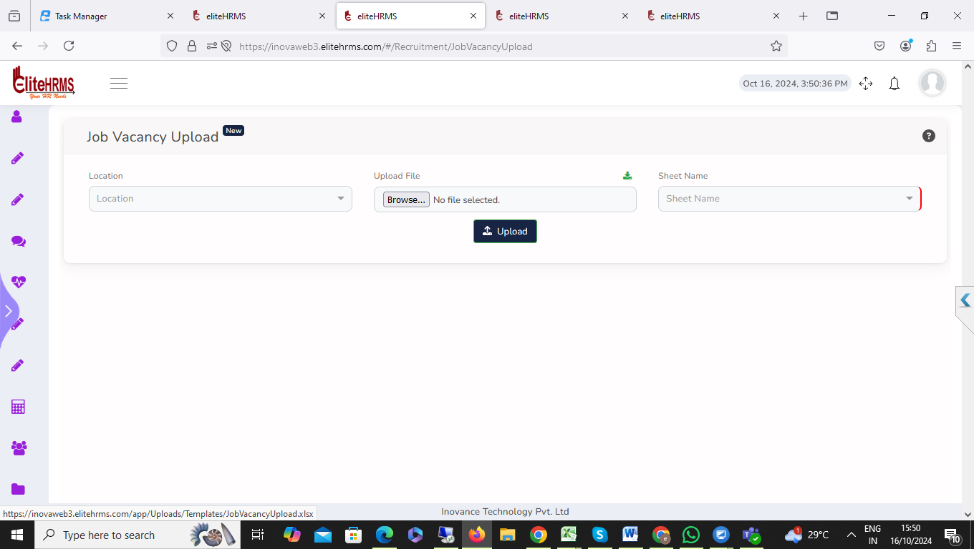

- Recruitment >Review Job Vacancy:

Please check the blank for the job vacancy report heading and file details.

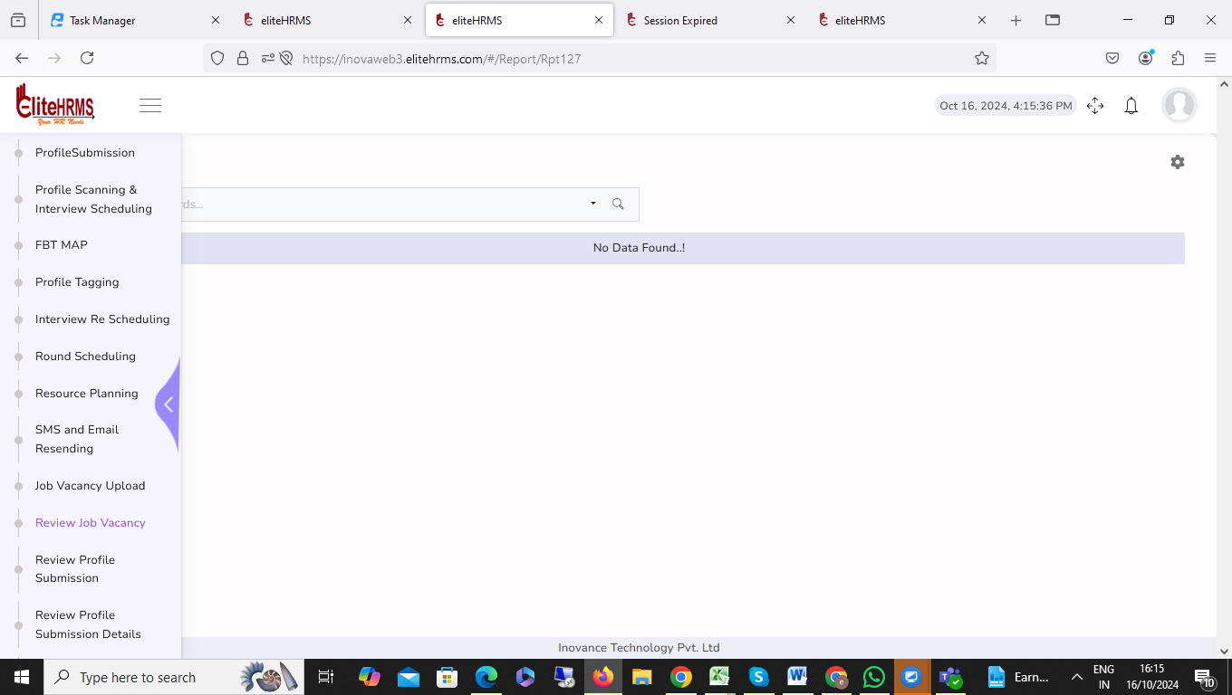

- Recruitment > Review Profile Submission:

Please check the blank for Review Profile Submission details.

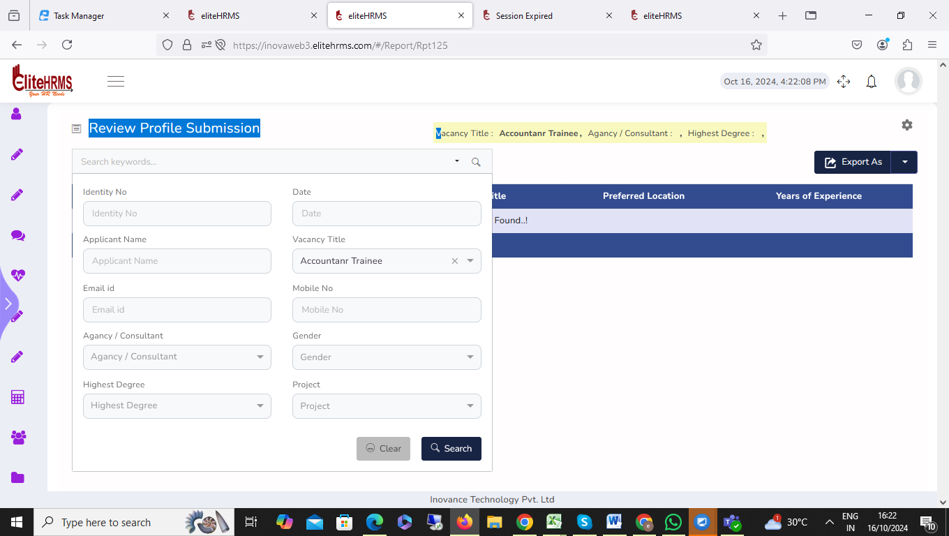

- Recruitment >Review Profile Submission Details:

Please check the blank for Review Profile Submission details.

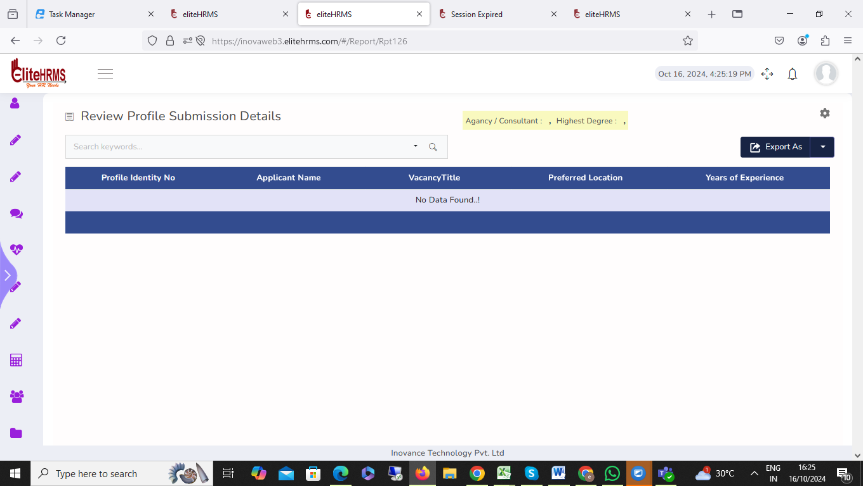

- Recruitment > Review Round Scheduling:

Please check the blank for Review Round Scheduling details.
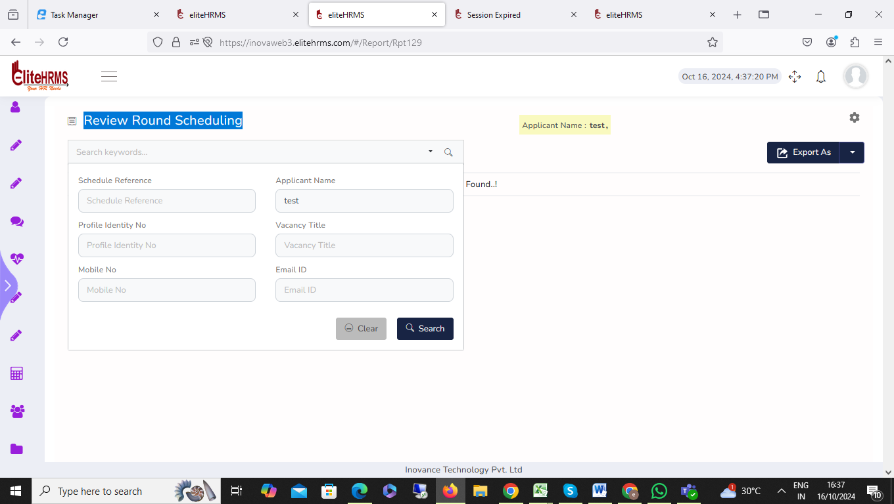

15.

